Site Map: Exogredient

Team A

Jason Nguyen (Team Leader) - 014232658

Eleazar Gomez - 012465490

David Nguyen - 015633187

Abe Malla - 016069649

Charles Kwak - 015368728

Hovhannes Babuchyan - 017228651



November 12, 2019

Table of Contents

**Desktop** **3**

Normal Flow 3

Upload / Profile / Manage Store 3

Ingredient / Store Search 4

Login / Registration 5

Error Flow 6

Registration Error 6

Registration Verification Error 6

Log In Error 7

Ingredient Search Error 7

Store Search Error 8

Profile / Claim Store Error 8

Upload / Draft Error 9

Ingredient Error 9

Manage Store Error 10

**Mobile** **11**

Normal Flow 11

Upload / Profile / Manage Store 11

Ingredient / Store Search 12

Login / Registration 13

Error Flow 14

Registration Error 14

Registration Verification Error 14

Log In Error 14

Ingredient Search Error 15

Store Search Error 15

Profile / Claim Store Error 16

Upload / Draft Error 16

Ingredient Error 16

Manage Store Error 17

# 

# **Desktop**

## Normal Flow

### Upload / Profile / Manage Store

## 

### Ingredient / Store Search

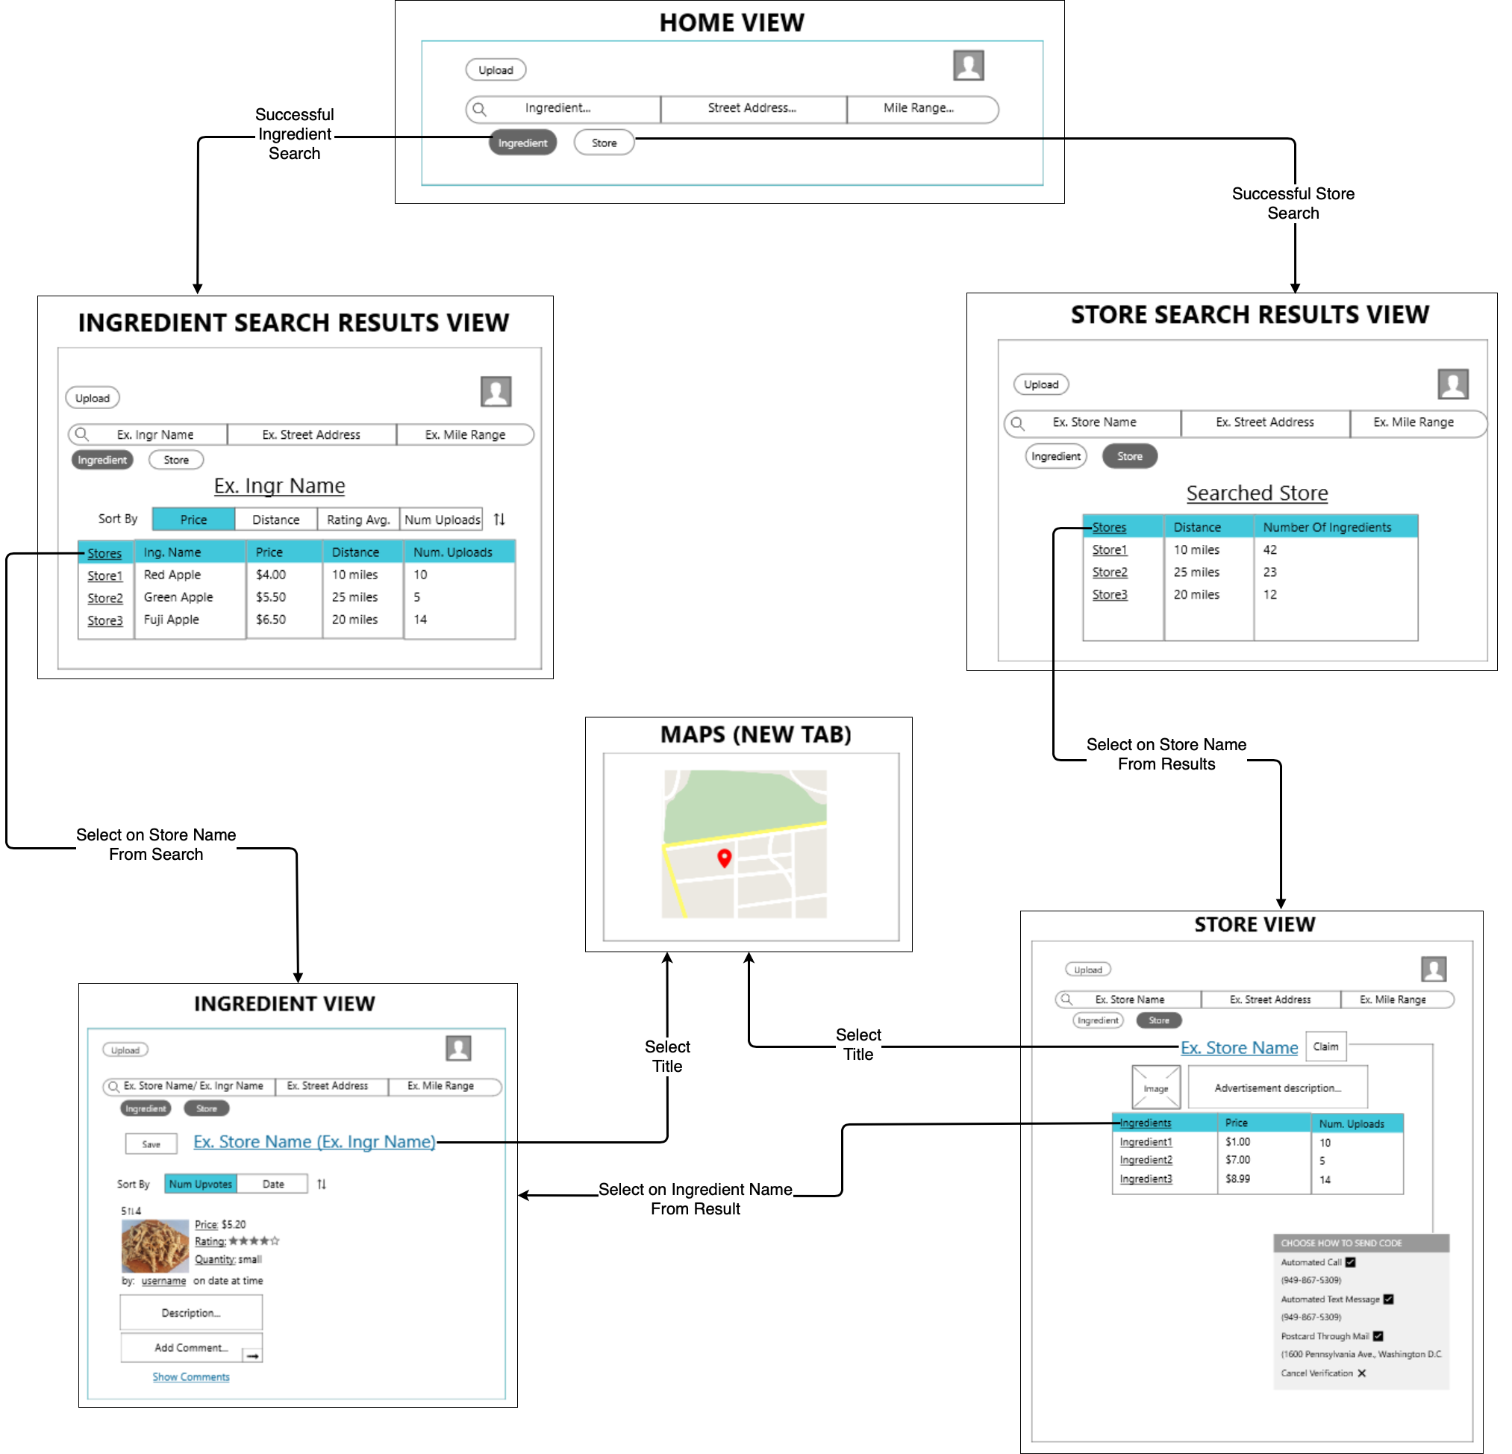

### Login / Registration

# 

# 

## Error Flow

### Registration Error

Precondition: At Registration View

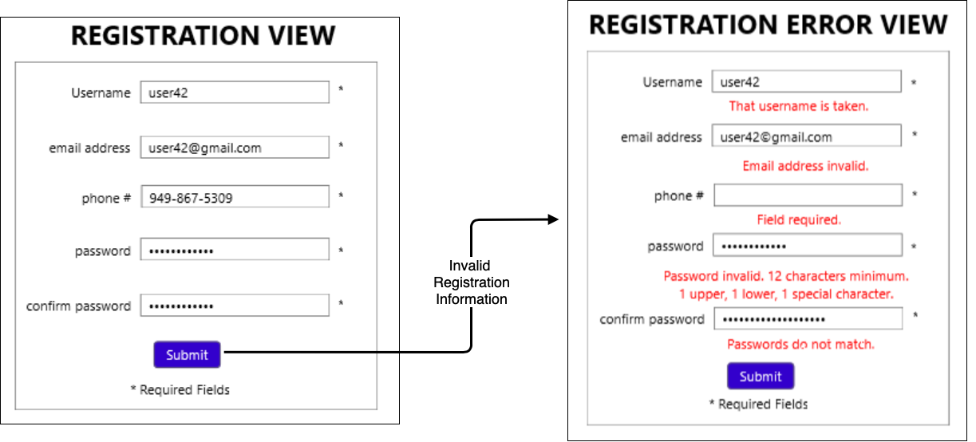

### Registration Verification Error

Precondition: At Registration Verification View

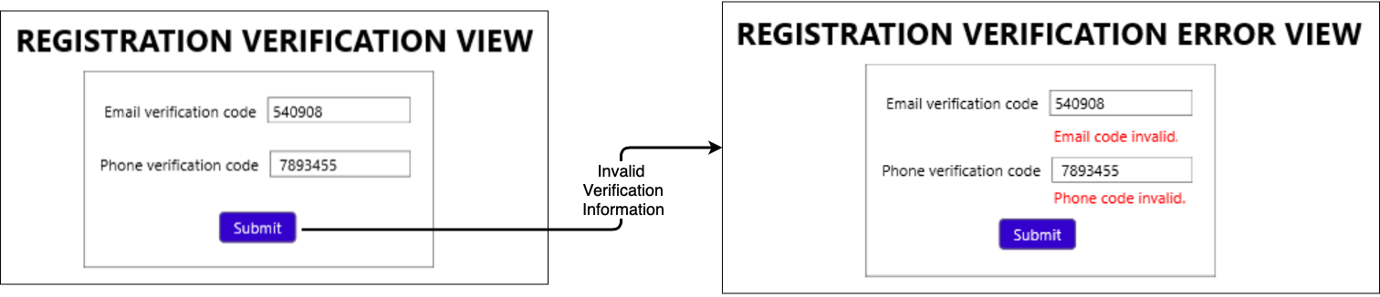

## 

## 

### Log In Error

Precondition: At Log In View

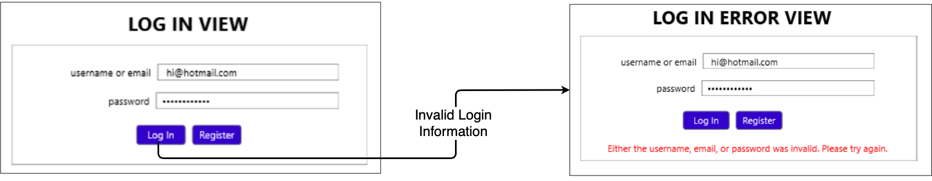

### Ingredient Search Error

Precondition: At Ingredient Search Results View

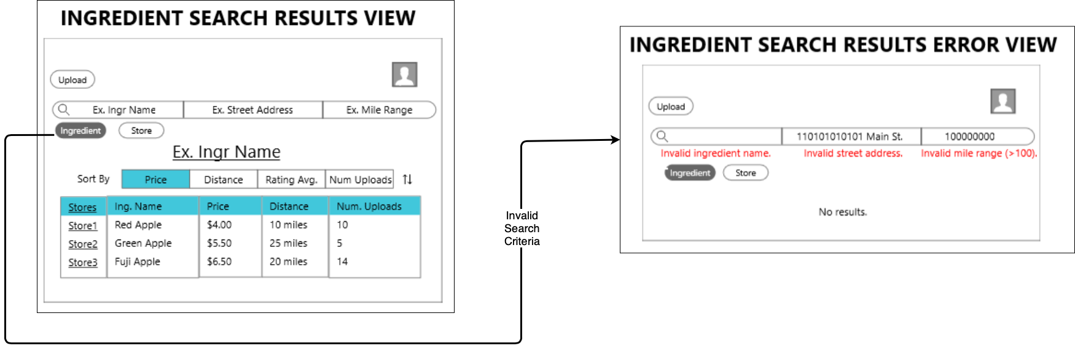

# 

# 

# 

### Store Search Error

Precondition: At Store Search Results View

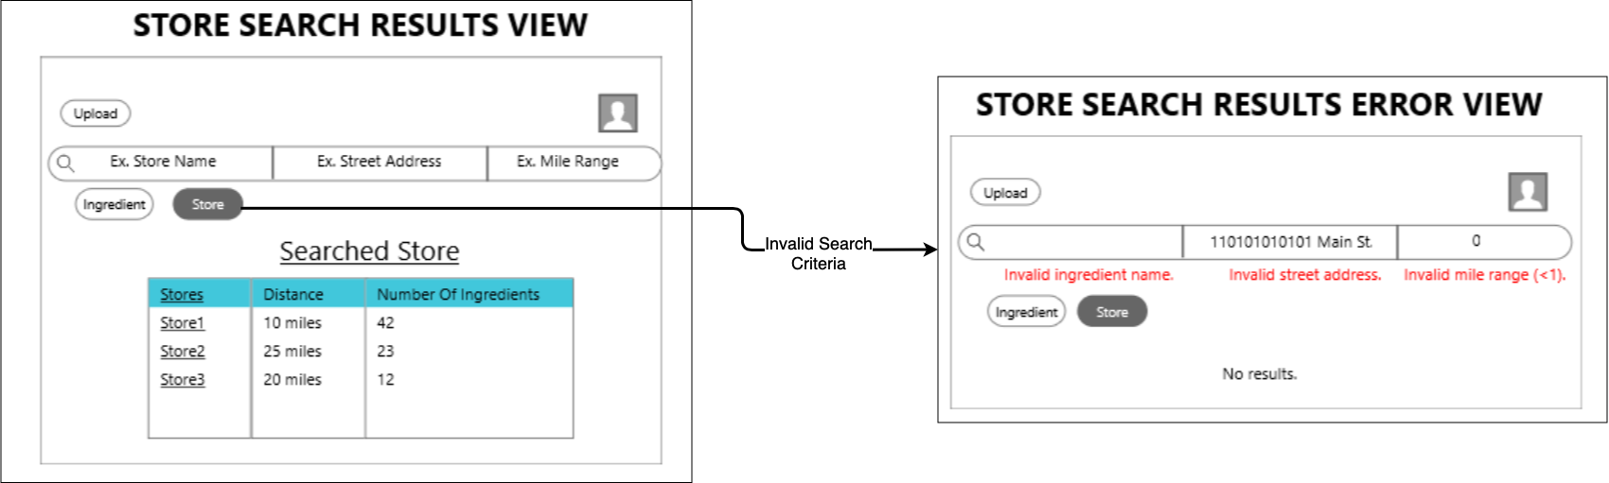

### Profile / Claim Store Error

Precondition: At Profile View

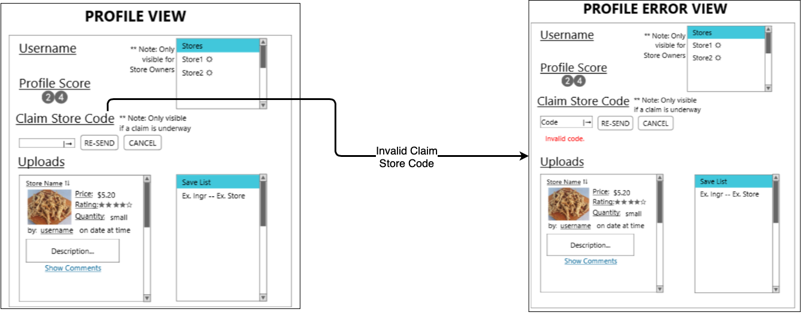

# 

## 

### Upload / Draft Error

Precondition: At Upload

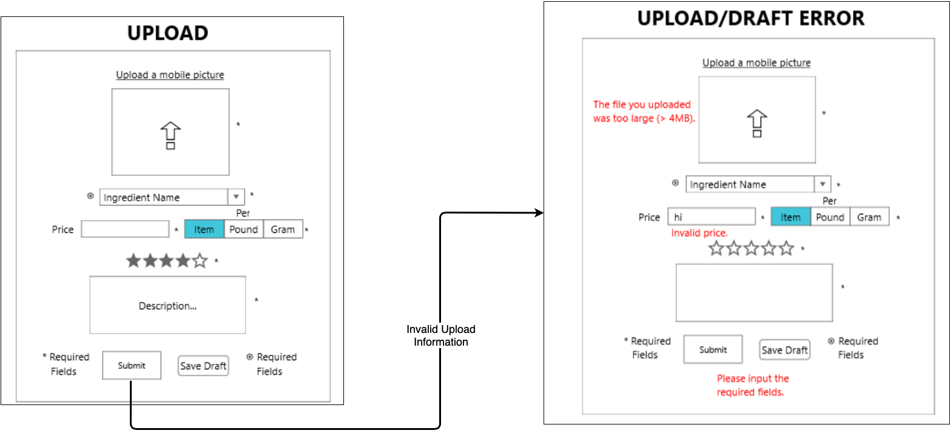

### Ingredient Error

Precondition: At Ingredient View

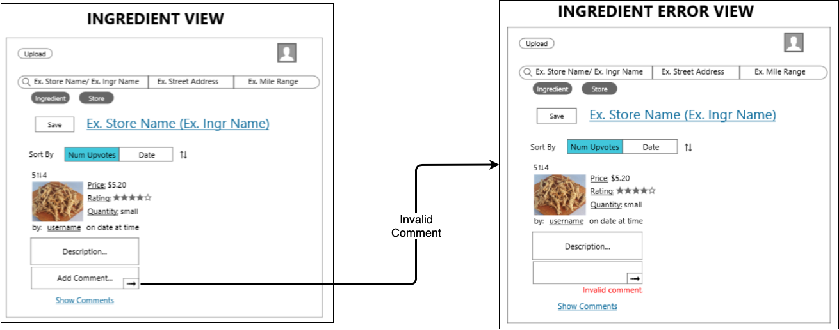

## 

### Manage Store Error

Precondition: At Manage Store View

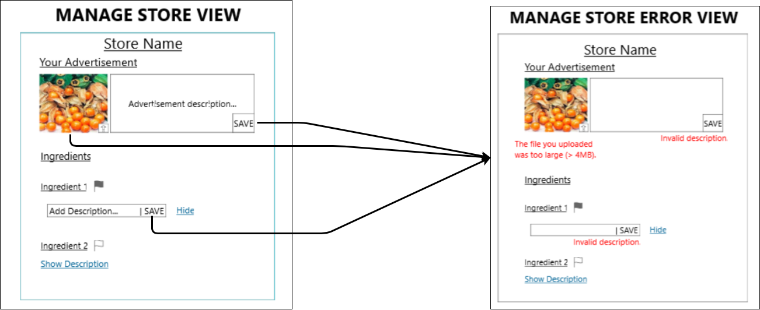

# **Mobile**

## Normal Flow

### Upload / Profile / Manage Store

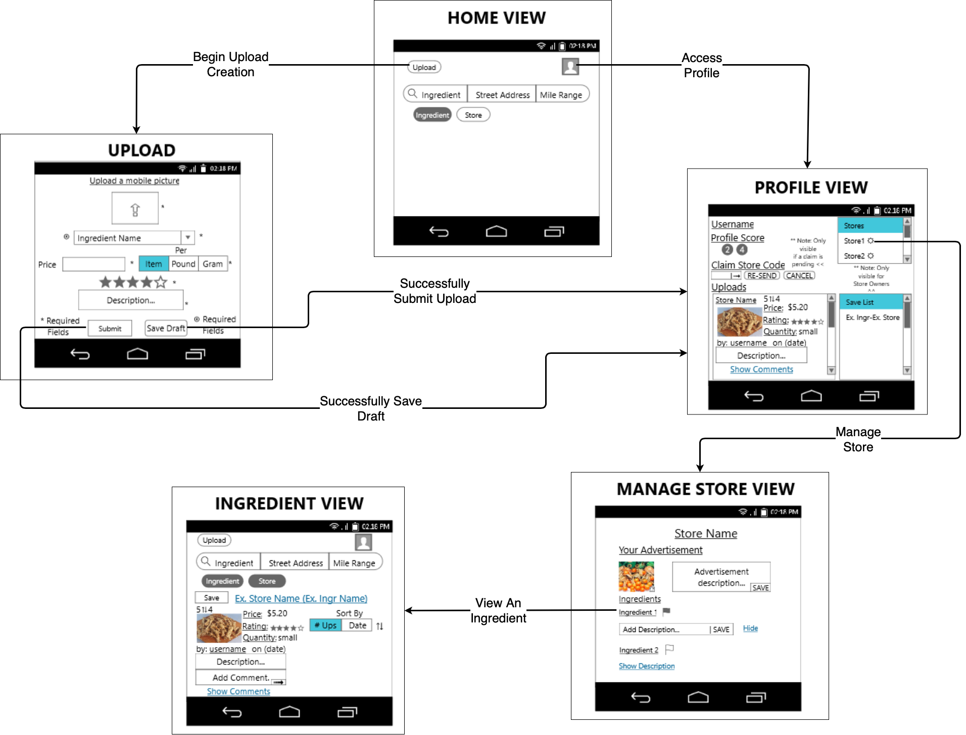

### Ingredient / Store Search

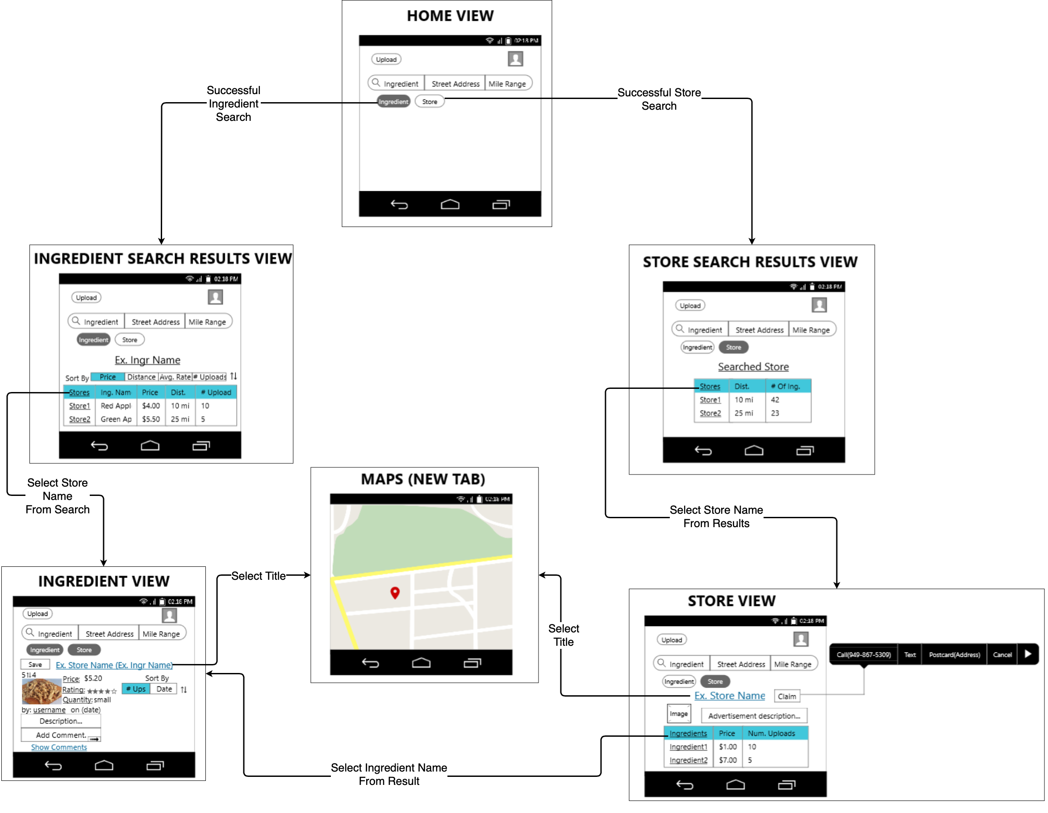

### Login / Registration

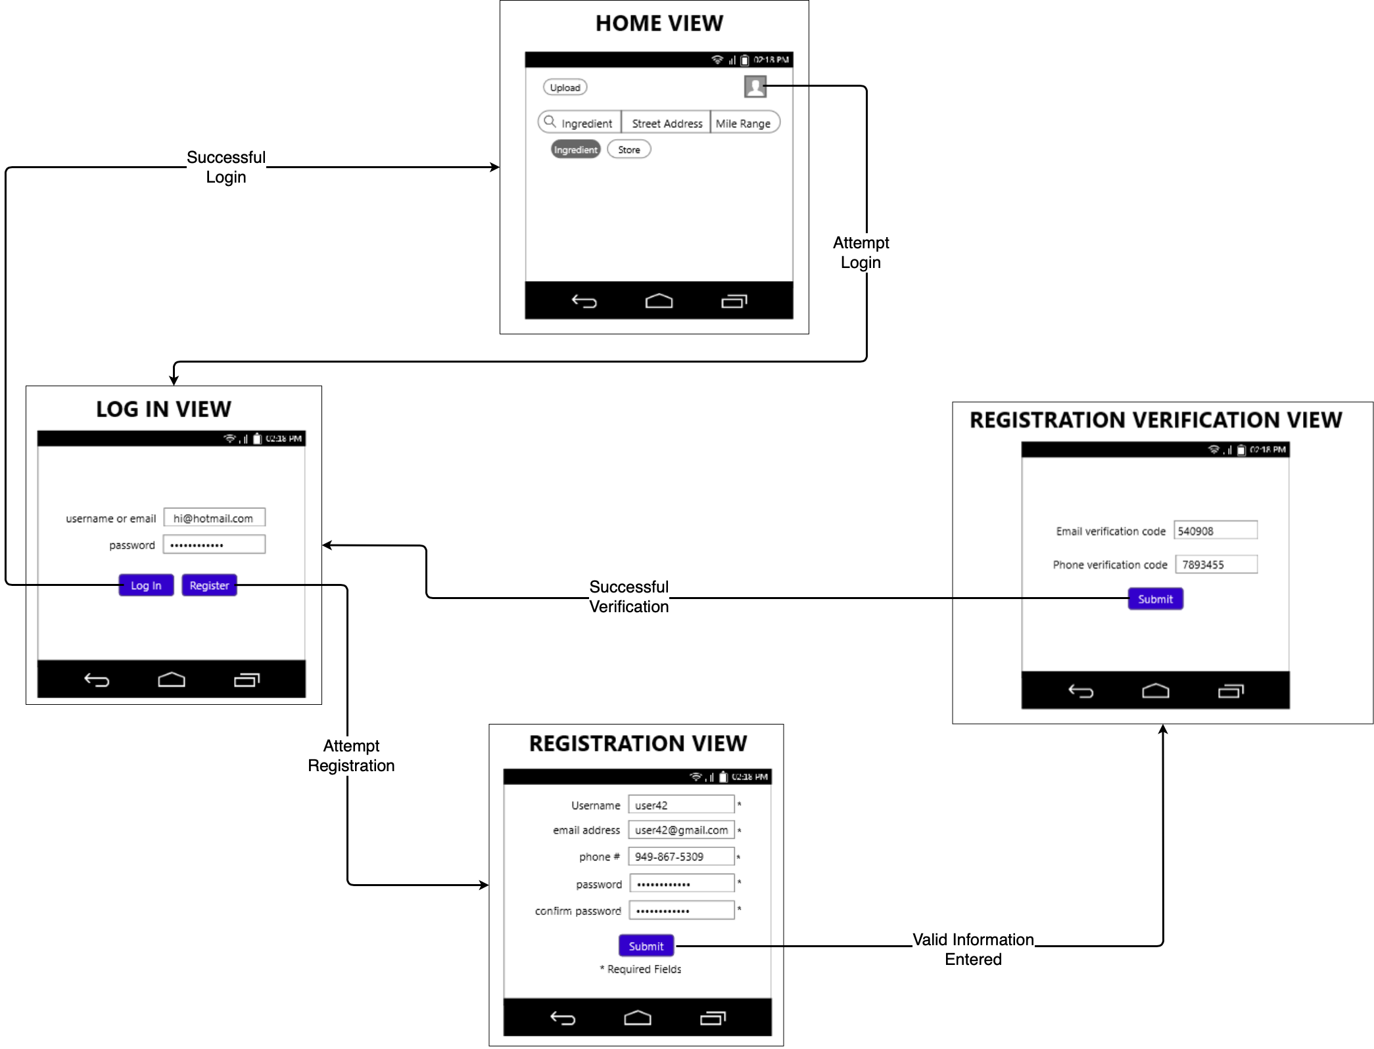

## Error Flow

### Registration Error

Precondition: At Registration View

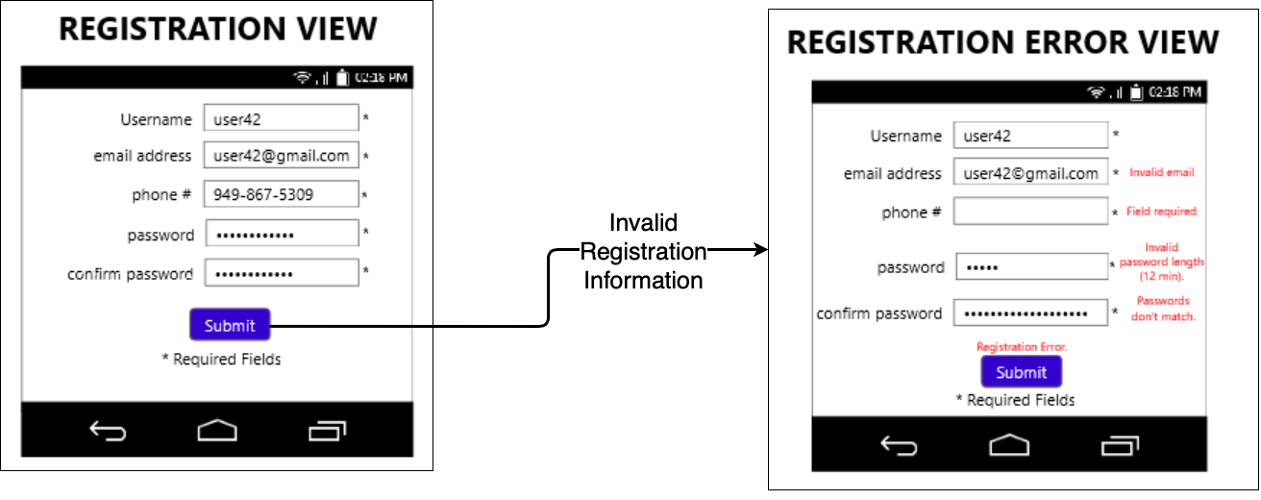

### Registration Verification Error

Precondition: At Registration Verification View

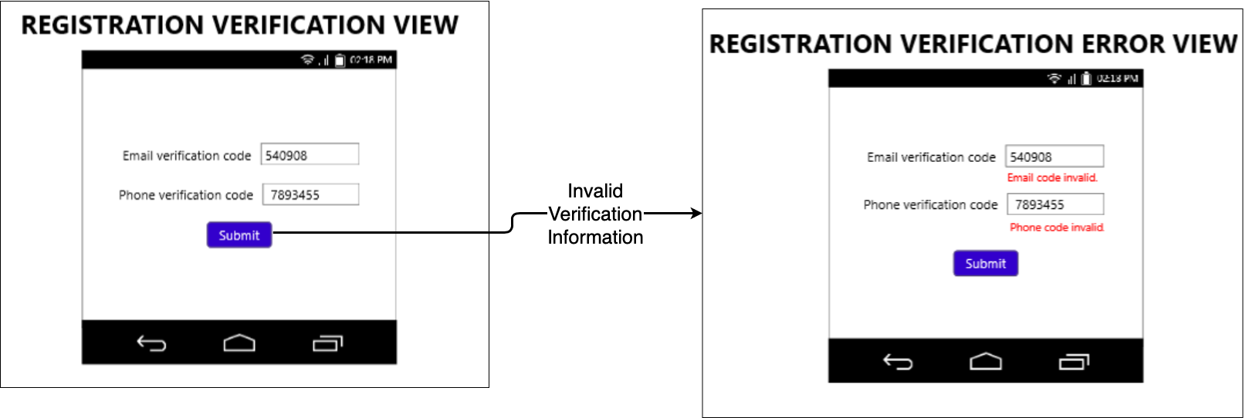

### 

### Log In Error

Precondition: At Log In View

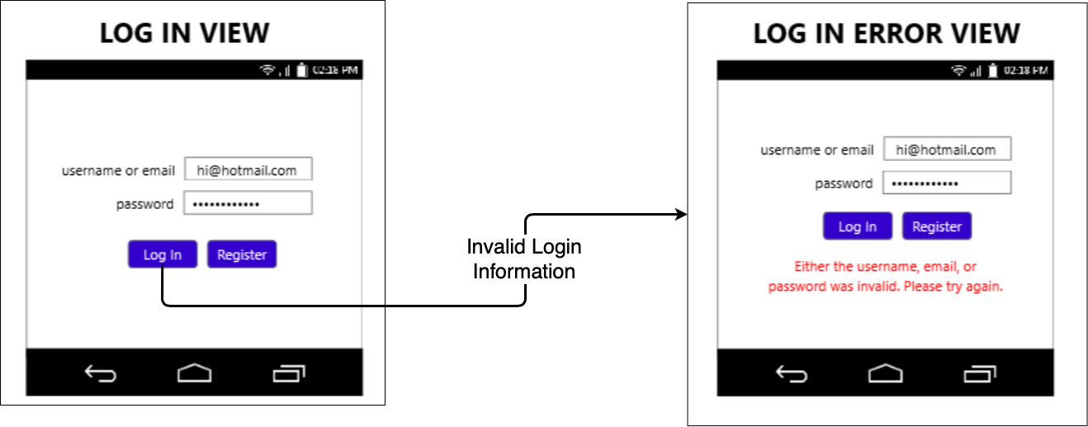

### Ingredient Search Error

Precondition: At Ingredient Search Results View

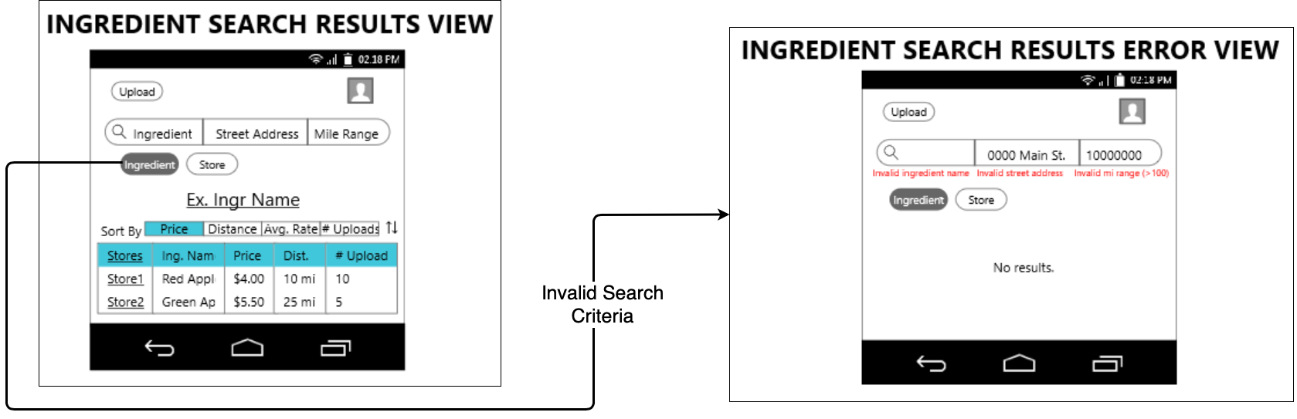

### Store Search Error

Precondition: At Store Search Results View

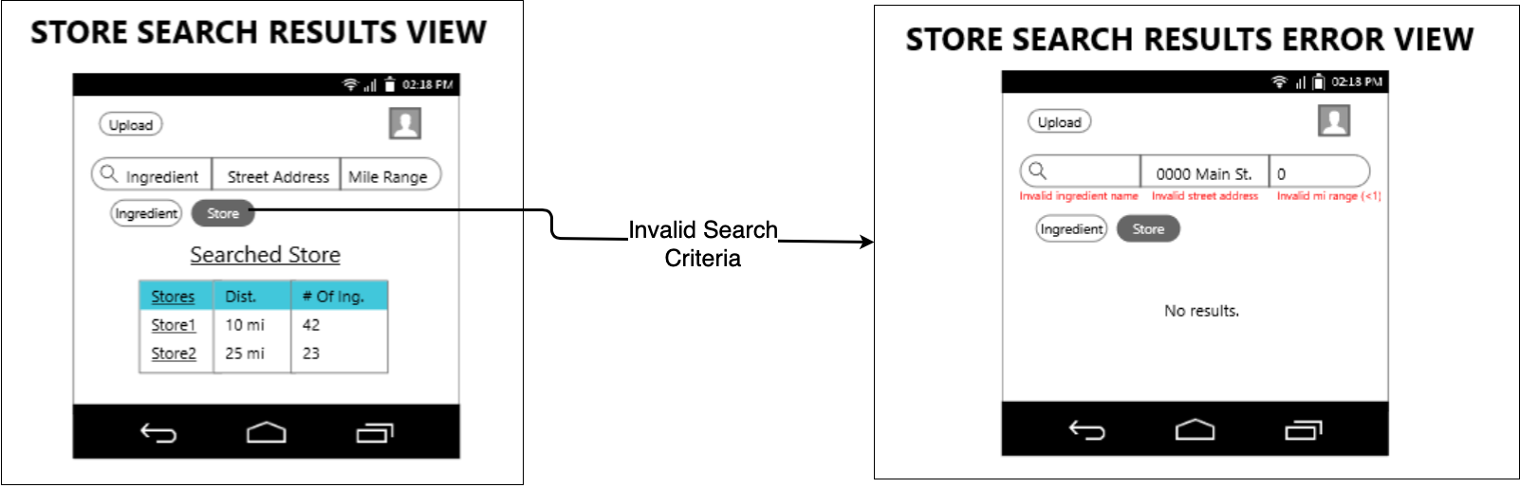

### Profile / Claim Store Error

Precondition: At Profile View

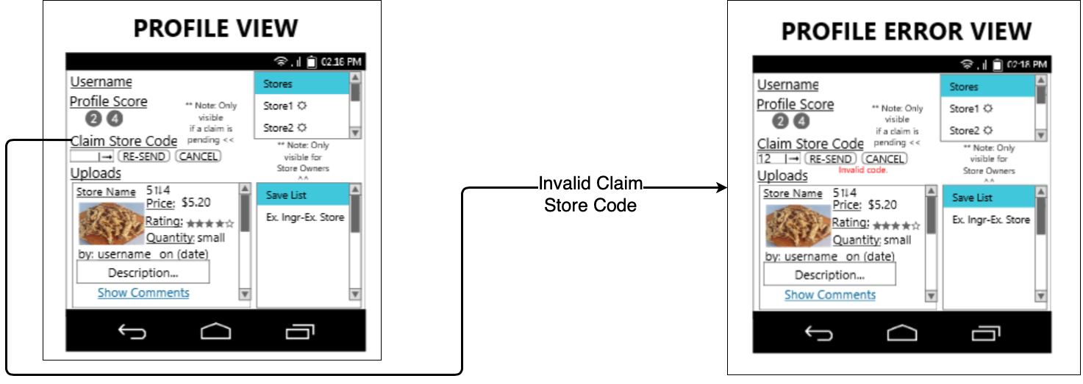

### Upload / Draft Error

Precondition: At Upload

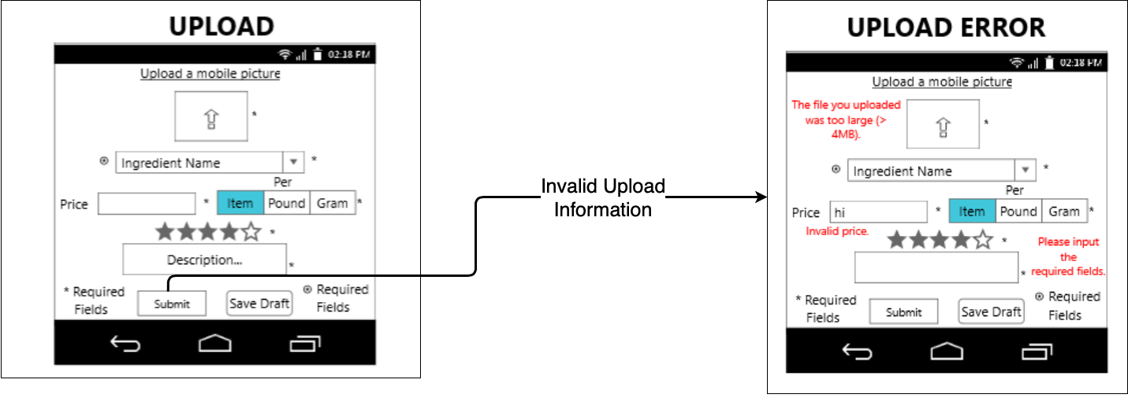

### 

### Ingredient Error

Precondition: At Ingredient View

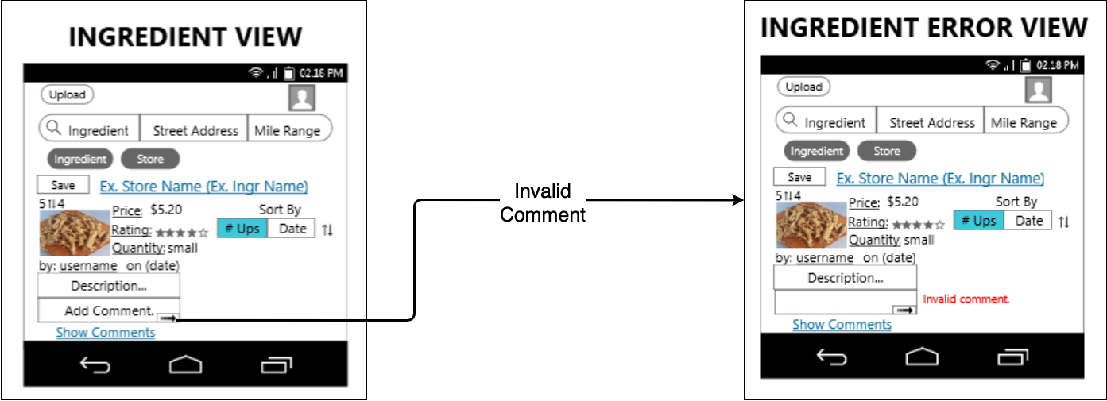

### Manage Store Error

Precondition: At Manage Store View

